For you night runners, a simple, straight run on the banks of the Seine is sure to appeal. Far from being quiet and precarious at night, the banks of the Seine seem to come alive with bars, restaurants and – you probably didn’t guess it – lots and lots of runners. With its flat surface, bright lights and regular water fountains, it makes for the perfect creature-comfort run to really immerse you in the fabulous city at night, showing you a different side to Paris in the process.

If you’re looking for somewhere a little more central, the famous Jardin des Tuileries is perfect for those early morning runs when it’s a struggle to get yourself out of bed. Significantly smaller than the Bois de Vincennes, Tuileries Garden is great for lapping, meaning you can concentrate less on where you’re going and more on the sublime scenery surrounding you – not too hard a task for that tired head. The garden is great as you can go for as long or as little as you like – reassuring for the short-distance runner. Stop off for a coffee in one of the cafés nestled inside after your run, and you’ll be ready for the day ahead in no time.
Jardin de Tuileries. Right in front of the Louvre. 0.65 miles east to west end. 1.6 miles around perimeter. Tuileries and Champs Élysées is a nice 3 mile loop.
https://www.mapmyrun.com/routes/fullscreen/996118735/
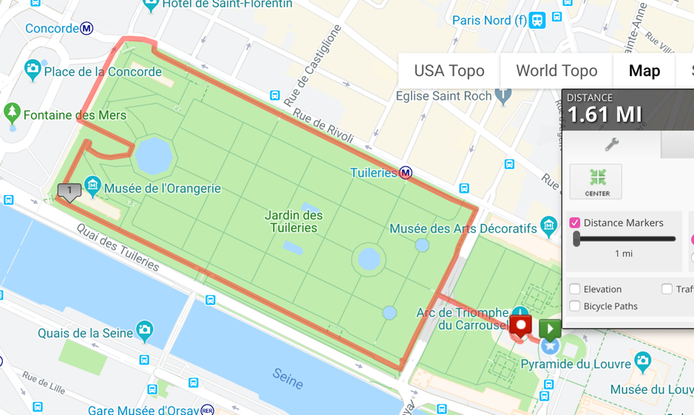
Off-the-beaten track, literally, is La Coulée Verte, a 4.7-kilometer elevated park built on old railway infrastructure. It’s situated in the 12th arrondissement of Paris, starting at Bastille and going on the the Bois de Vincennes. Although not the longest of routes, it’s ideal to tie in midway as it will give you a welcome change from the busy streets; your chances of knocking over an ongoing pedestrian are significantly reduced on this path. As well as the open space, you will enjoy changed scenery, with enclosed sections lined with modern buildings and open ones giving you expansive views of Paris in all its glory. Fittingly for today, the Promenade runs from just east of the Place de la Bastille some 2.9 miles through the 12th arrondissement to the Peripherique highway. The Promenade Plantee, also known as the Coulée Vert, the Green Flow, extends 4.5 kilometers, running almost the entire length of the 12th arrondissement, from the Périphérique on the eastern end to the Place de la Bastille on the western end, with only the last couple hundred yards being taken up by the Opéra Bastille.
The elevated portion of the Promenade Plantee runs from the Opéra Bastille to Jardin de Reuilly, a distance of 1.5 kilometers. Beneath this section of the Promenade is the Viaduct des Arts.
This elevated part of the Promenade Plantee is a narrow walkway, occasionally opening to wider, wooden-planked areas when it crosses over a street. Generally, a stairway down to street level (or up to Promenade level) will be found here.
There is an elevator, which occasionally works, located on Voie AA/12 just west of Boulevard Diderot.

Promenade Plantée
2.4 miles O-W. Start: Bastille or Porte de Montempoivre (metro Bel Air).
Add-on options: Bois de Vincennes, Parc des Buttes Chaumont
https://www.mapmyrun.com/routes/fullscreen/996182771/
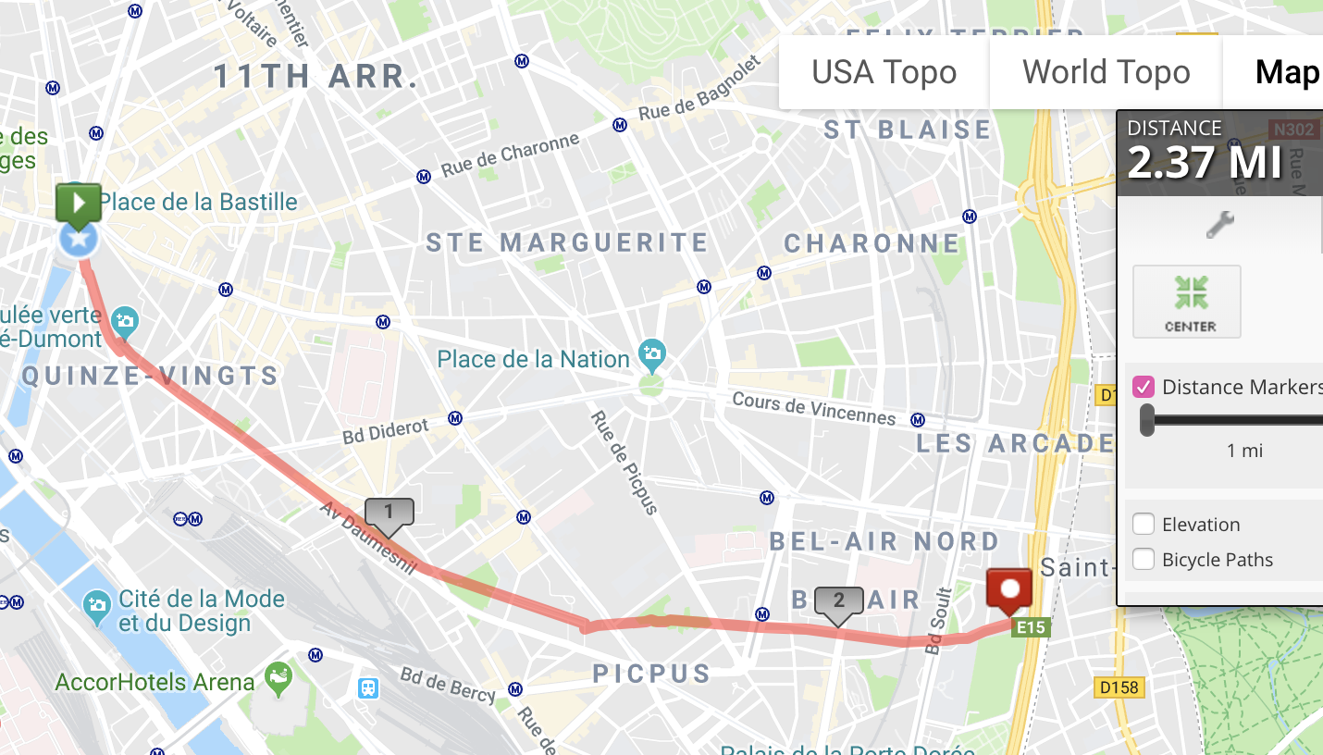 This is a favorite Paris off-road path. Created out of an abandoned metro line, PlantPé is an elevated, paved linear park that runs 2.4 miles from Bastille in the Eleventh arrondissement to Porte de Montempoivre. You’ll see lots of other runners, and inline skaters. Just beneath the path, along the viaduct, there are shops, markets, and artist studios. There are numerous entrance gates along the way, each with their own opening/closing times. For a longer run, continue from the end of the path into Bois de Vincennes, which is 0.5 miles using Rue Sacrot (look for the Porte Dorée entrance), or mid-way along the Plantée path, from Jaures, head 1/2 mile east to Parc des Buttes Chaumont. Good hills there. Notes: There are signs that say “This place is a space for walking. Jogging is tolerated only to the extent that it doesn’t disturb walkers.

The biggest – but by no means best – park in Paris, the Bois de Vincennes is situated at the eastern edge of Paris and is the place to go for you runners who never seem to get tired. While Paris’ streets are great to run around, Bois de Vincennes offers the nature that can often be lacking in a city; with its English landscape garden, botanical garden and four lakes, you’ll no longer feel like you’re in a bustling city at all, and with all those trees, your lungs are sure to thank you for it.

Boise de Vincennes
4.76 mile loop. Start: Chateau Vincennes metro
Good add-on option: Run there from City Hall (Hotel de Ville). 3.7 miles one-way.
https://www.mapmyrun.com/routes/fullscreen/996159565/

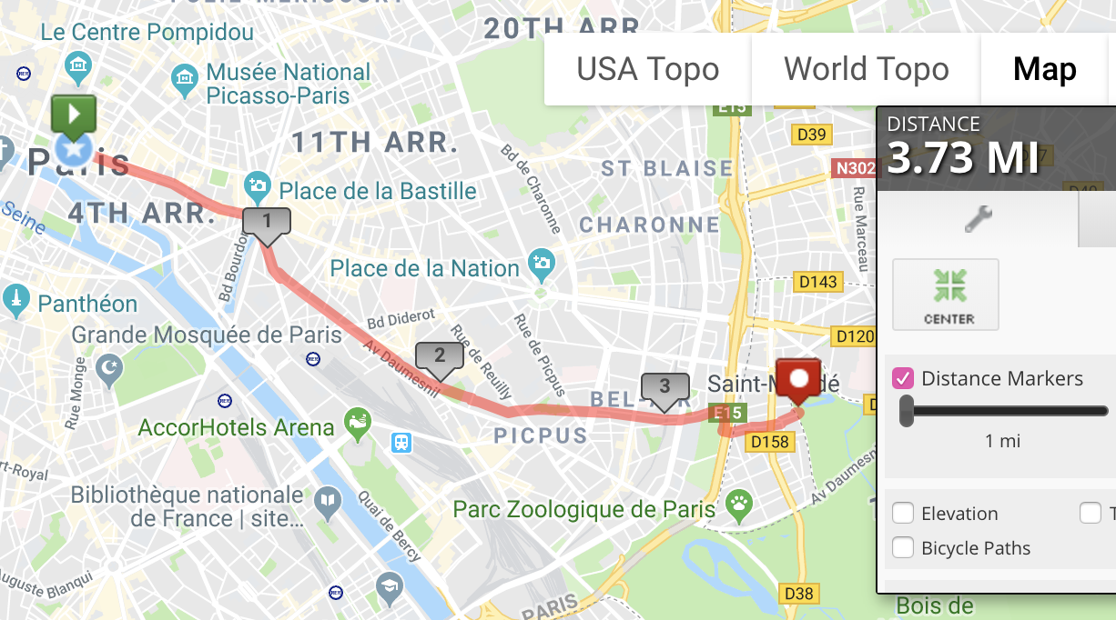

Located in the 5th arrondissement and comparable to the Tuileries for running, Jardin des Plantes is perfect for laps, due to its rectangular shape. What, however, is not similar are the surroundings you will see. Jardin des Plantes is Paris’ main botanical garden; in other words, it is absolutely beautiful. What with all the sights and smells of the phenomenal array of flowers, along with the intricate, glass buildings that line paths throughout the garden, you may find yourself so distracted that you forget you are running at all, which is never a bad thing.
- Jardin de Plantes. Across the bridge from Bastille. 0.8m around perimeter. The city’s largest botanical garden. Great in the rain as trees provide shade. Unpaved paths.

Canal St. Martin usually goes relatively undiscovered by tourists, as it is quite far from the attractions nearer the center. It’s very authentically Parisian, and the best way to fit in is to join the stream of runners who pace along its banks. The surroundings are picturesque and will show you a different, quirkier side to Paris, with its brightly painted buildings and chic terrace restaurants. You’re sure to pass more than a handful of cool spots to stop for breakfast after the 4.5 kilometers that it covers, as it’s becoming a progressively fashionable location with eateries popping up all over the place. However, if you’re not ready for breakfast yet, Canal de L’Ourq – which it streams into – will offer you a run that’s sure to get your appetite going.

Canal St. Martin & Parc de Villette

Short option: 3.2/6.4 miles out & back/RT. Start: Bastille.
https://www.mapmyrun.com/routes/fullscreen/996192671/
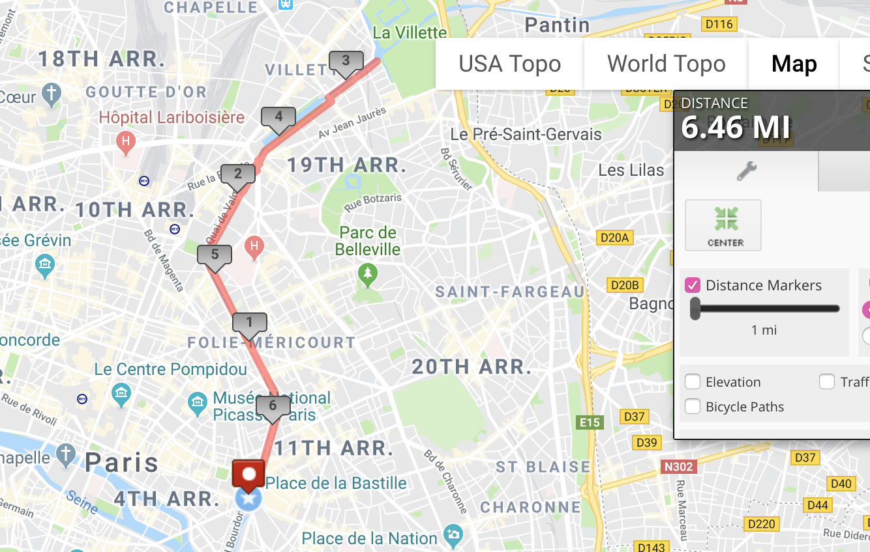
Long Option: 5.2/10.4 miles out & back/RT. Start: Bastille.
https://www.mapmyrun.com/routes/fullscreen/996194359/

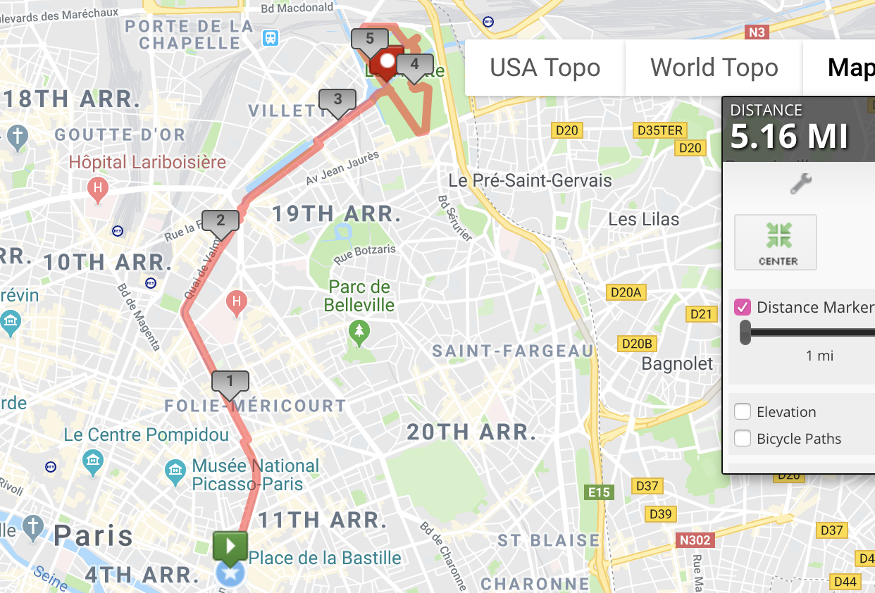This is another wonderful linear park option from the heart of Paris. It follows the Canal St. Martin, which meanders its way from near the Bastille to Parc de Villette. The towpath is very pretty, with lovely chestnut trees shading some sections. The first section on our map is hard to see because it is below the street. Runners have a few options here: run one-way, 3.2 miles, and then hop on the metro back — multiple stations along the way and at the Parc. Or, it’s 6.4 miles RT. A longer option is to to enjoy some of the paths in Parc de Villette. A more modern, landscaped park, with interesting sites such as the Géode, a 36-diameter sphere, garden of mirrors, the garden of trellises, and the garden of islands, connected by ~2 miles of paths. Then return, for a long 10.4 mile run, or hop the metro.

Much longer than Canal St. Martin at a lengthy 108.1 kilometers, Canal De L’Ourq offers the distance you need to clear your head over and over. No cars and few pedestrians, you can run for hours on end in the serenity the banks offers, and the further you go, the greener it gets – drifting out of Paris, you’ll be immersed in the nature that comes with outer-city running. A breath of fresh air and a chance to push yourself distance-wise, Canal de L’Ourq is perfect for those times when the bustle of the city gets to be a bit too much.

Not quite as large as the Bois de Vincennes – but just as lovely – Les Bois de Boulogne sits on the other side of the city in the 16th arrondissement. The area is fantastic for running as it offers lots of different options: the footpaths that trace around the two lakes create the perfect ‘lap,’ while delving a little deeper into the woods will find a running track with regular, wood-built obstacles – a nice challenge and change from your usual run. The park is vast, but with maps and water fountains scattered throughout, there is no need to fret about so losing yourself a little between the trees.

Bois de Boulonge
Long: 8.8 miles RT, starting at the Arc de Triomphe.
Short: save two miles by starting at Port Dauphine
10k in the Park: follow “Tour de Longeur” from the Port de la Muette entrance
This is the loveliest, shadiest place for running in the heart of Paris. You’ll find hundreds of fellow joggers on a nice evening. There are some 35 miles of trails in the park. It’s hard to proscribe a particular run, but your best bet is to run around Lac Inferieur and Lac Superieur (5k). Then there’s the option to head toward the northwestern part of the park, using any one of a number of paths. On the good maps at all trail intersections, look for the 10k “Tour de Longeur”, most easily accessible from the Port de La Muette entrance. Our route starts at the Arc de Triomphe just for kicks. Easily accessible by Metro. Combine with Parc St. Cloud for an even longer run.

https://www.mapmyrun.com/routes/fullscreen/995976011/
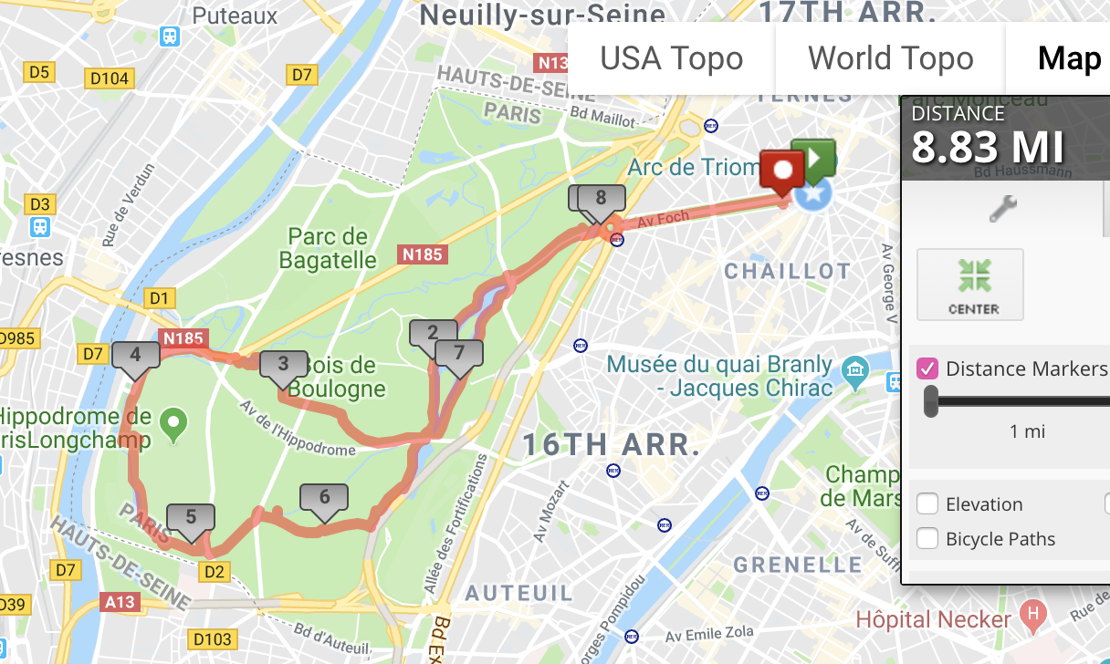
This is the largest park in Paris, about 4 miles east of Notre Dame in the 12th arrondissement. The park was created between 1855 and 1866 by the Emperor Napoleon III. There are beautiful paths for running in this park. Highlights include the medieval Chateau de Vincennes, an arboretum, floral gardens, and numerous other natural and recreational facilities. The best bet is to randomly enjoy the miles of paved and unpaved paths. A tour of the outer perimeter trails is ~4.5 miles. Other options: 1 mile around Chateau de Vincennes; 1.4m around Lac Daumsenil. Or look for the “Circuits Pedestres”, which include 11k and 8k loops. Many more trails can be added. The trails are well signed, with mile markers. 15 minutes by metro. A good option for a longer run is from City Hall, which takes you by Bastille and then on some greenways and good running roads into the park. Do it one way and take the Metro back! Or, take the Promenade Plantée path back to Bastille, from Port Dorée entrance.
- Bastille. Separate path for pedestrians. About 1 mile around. Bathroom at north end.
- Luxembourg. Beautiful gardens and paths, laid out in a geographic pattern. Medici Fountain. Can be crowded. 1.3 miles around perimeter path.
https://www.mapmyrun.com/routes/fullscreen/996122305/
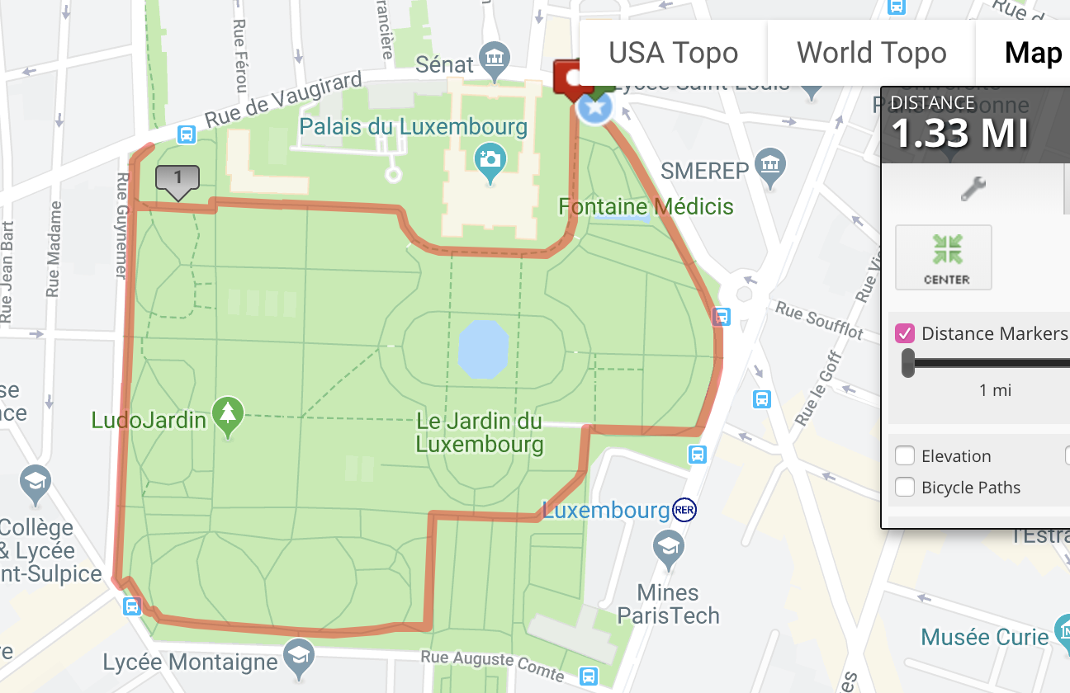
- Champs de Mars. 1.3 miles around perimeter paths of Champs de Mars.
- Invalides. One of the best for running. Wide paths, fewer people. 1.7 miles around perimeter.

Parc des Buttes Chaumont
5km of trails and good hills. Easy access via metro. Also 1/2 mile east of Promenade Plantée, 1/2 mile south of Parc de Villette.
A great park to do some hills. Unveiled at the 1867 World’s Fair, this park is sometimes referred to as the ‘Central Park’ of Paris. About 5km of trails, with the hilliest in the interior. Great to combine with Parc de Villette, or Promenade Plantée.

Banks of the Seine
7.3 miles, RT. Start: Notre Dame, Ile de la Cite.
Options for longer — head west on south side from Champs de Mars.
https://www.mapmyrun.com/routes/fullscreen/995870783/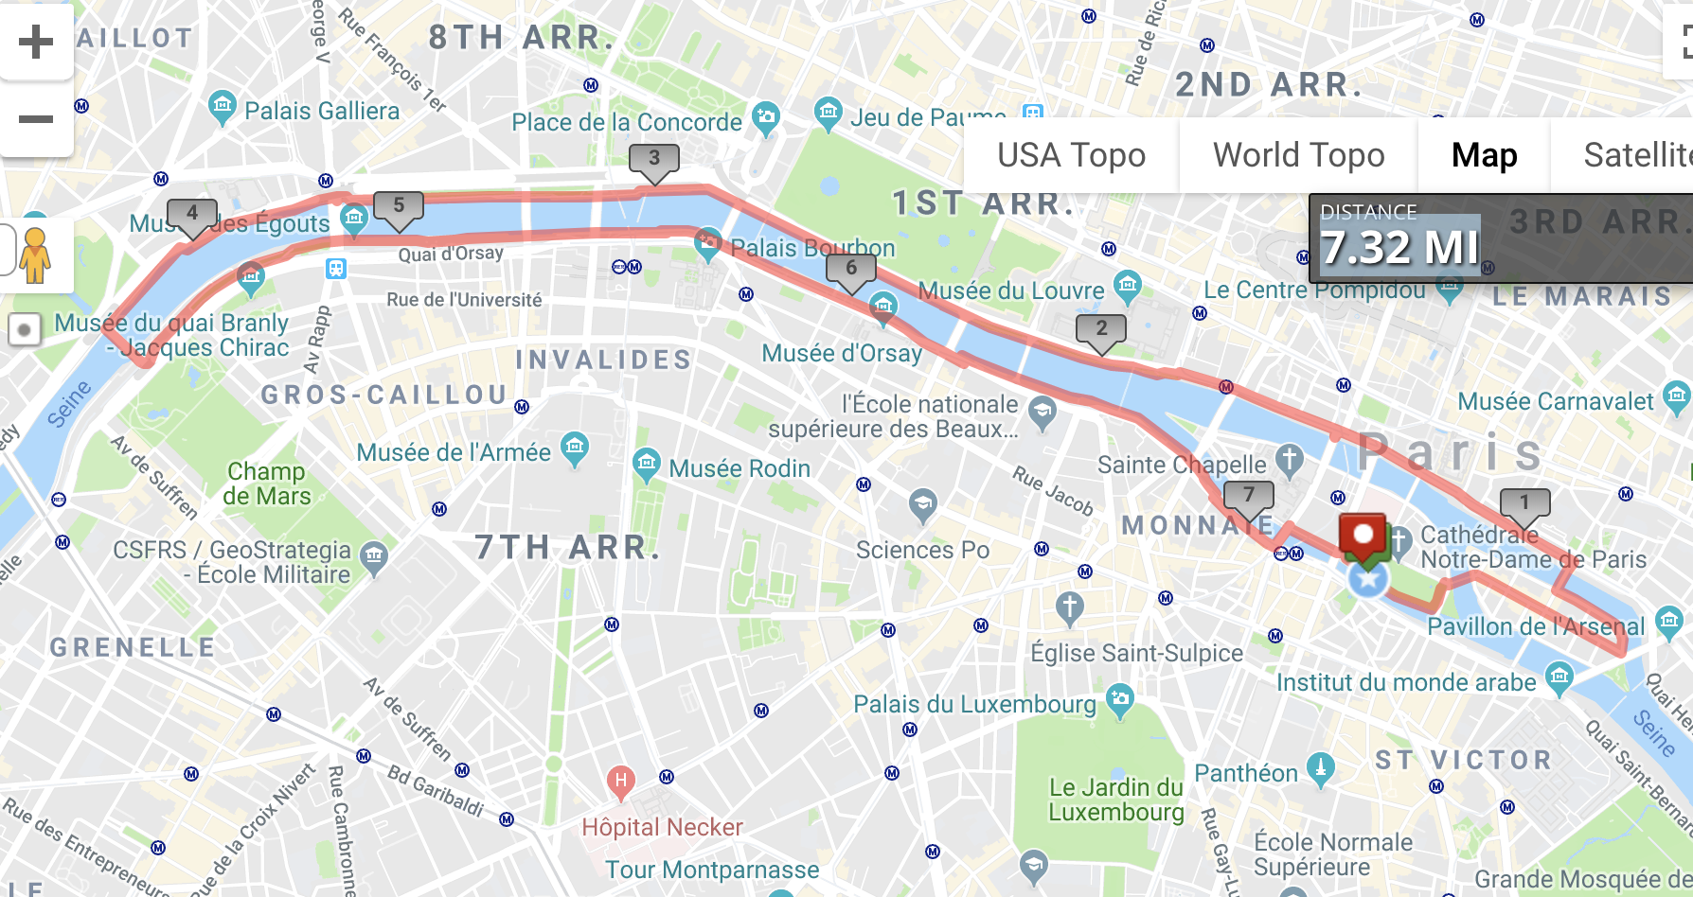
Running on the banks of the Seine is one of the great runs of the world. Over the past few years, several sections have been turned into pedestrian-only paths, below the road, making running along the Seine in the heart of Paris a running heaven. Along the river, there are also great views of Paris’ wonderful buildings and landmarks. Starting at Notre Dame (or any point), head east on Ile La Cite over to Ile St. Louis, crossing a bridge over to the north side, or right bank. Then head west along the river, passing numerous landmarks: Centre Pompidou, the Louvre, Jardin de Tuilleries, Place de La Concorde, and the Modern Art Museum. At just over 4 miles, opposite Jardins de Trocadero, cross the Pont d’Ilena, over to the left bank. Head back east. Some of the nicest sections of the river run are along a section called Les Berges, between the Pont de l’Alma and the Musée D’Orsay. This section was formerly a highway but was beautifully developed into a path two years ago. Shorten the run doing less of the path or add to/vary it with incredible detour opportunities: Tuilleries, Champs-Elysees, Jardins de Trocadero, Champs de Mars, and Invalides. Adding all those would make this a 10-miler or so.

Seine, Western Section
7 miles, out and back. Start: Champs de Mars.
https://www.mapmyrun.com/routes/fullscreen/995899111/
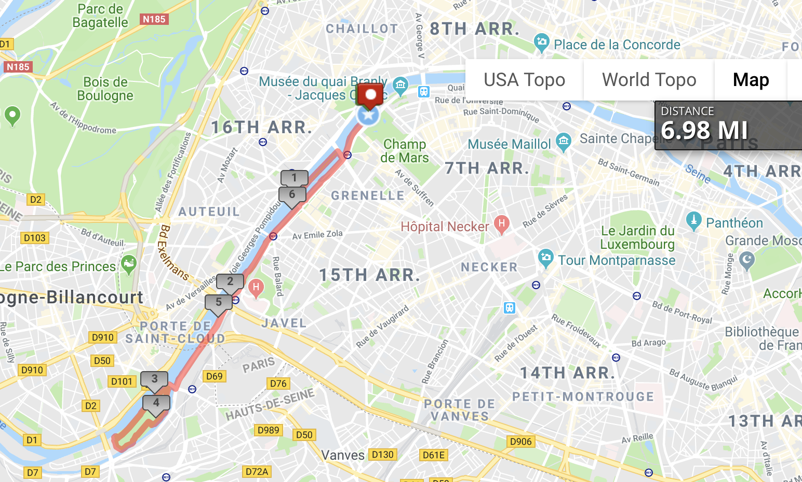
This can be part of a longer run or a distinct run. We continue the above, running west of Pont d’Ilena, along the lovely thin path of Ile aux Cygnes, then doing a tour of the park on Ile St. Germain. It can be joined with any parts of Seine run above, or any of the wonderful detours.

Highlights of Paris Route
7.5 miles. Start: Pont Neuf.
https://www.mapmyrun.com/routes/fullscreen/995962089/
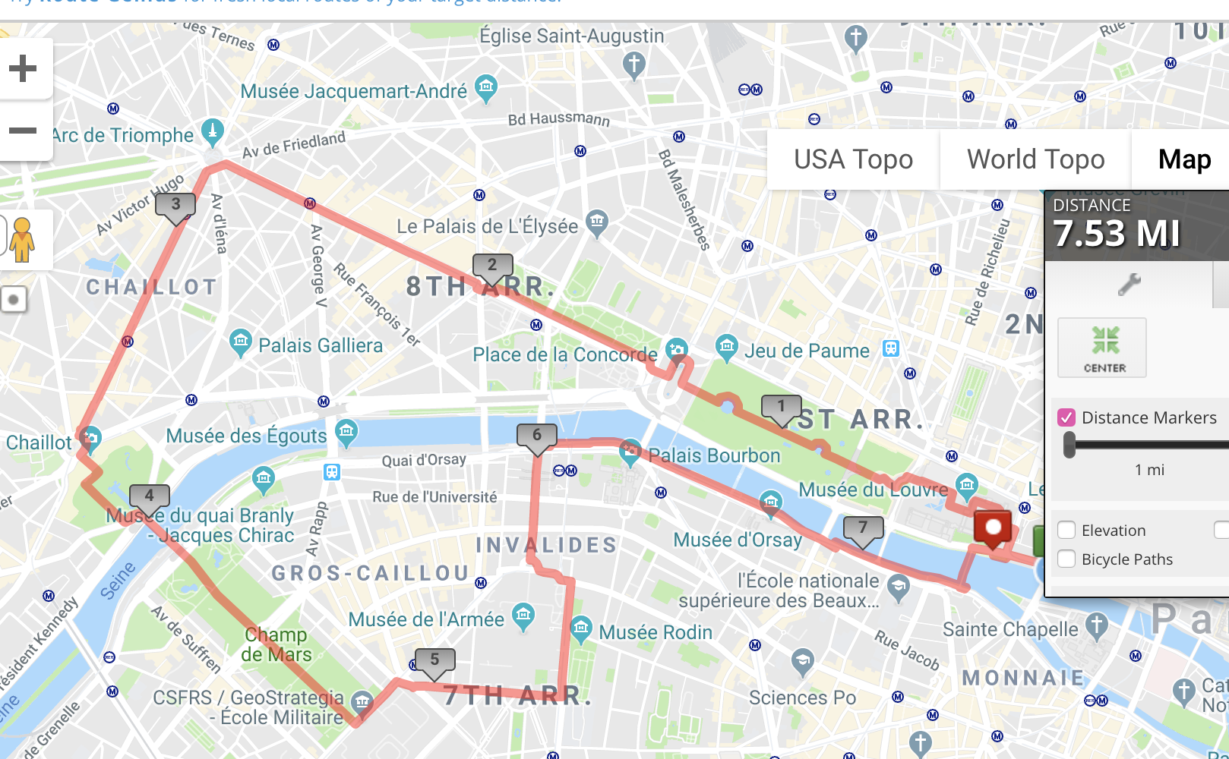This route has all the best of the heart of Paris, combining parts of the Seine paths with some of the city’s most famous landmarks and beautiful places. Start on Pont Neuf, and head to the north side (‘right bank’) of the river. Run by the Louvre into the Jardin des Tuileris, straight into the Place de la Concorde and then along the wide paths of the Champs Elysées, continuing along the famous shopping section, to Charles De Gaulle Etoile/Arc de Triomphe. Take Rue Kleber south, to the Trocadero, and the gardens, with a great view of the Eiffel Tower. Cross the Pont d’Ilena, do a quick little tour around the Tower, and then along the wonderful paths of the Champ de Mars and then the paths through Invalides. The last mile is along the left bank of the river, passing the Musee d’Orsay.
Some of these areas are major sites on their own, so of course it’s possible to do just some sections.

La Défense/Nanterre
4.2 miles RT. Start: Esplanade de La Defense metro.
https://www.mapmyrun.com/routes/fullscreen/996271743/

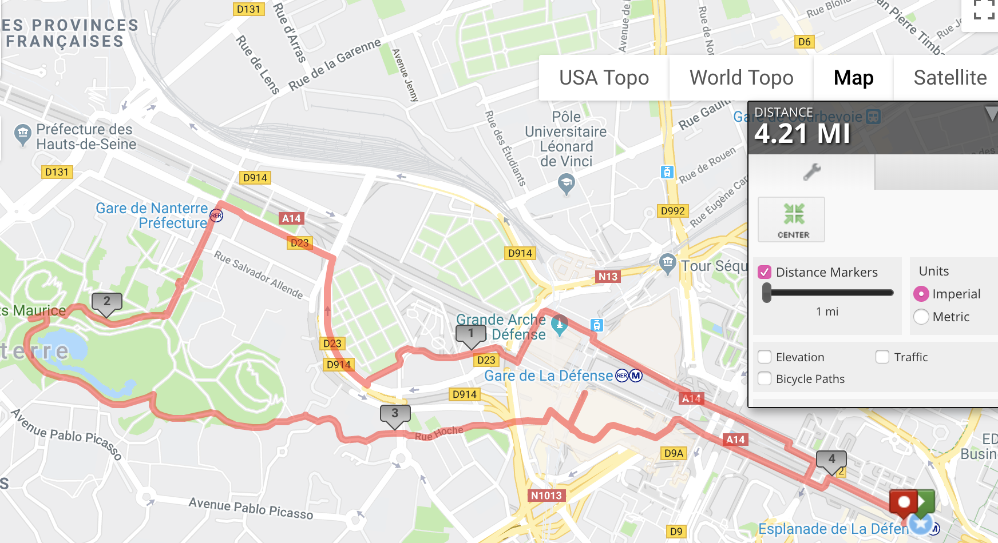
Add-ons: it’s 3k to the Palais de Congrès, which also abuts Bois de Boulongne, and 4k to the Arc de Triomphe.
La Défense is Paris’ version of London’s Canary Wharf/Docklands. It’s a business-centric district of modern office buildings on the edge of town. It started in the 1970s but it is still growing. As with most things Paris, this area has been built on a grand, post-modernist scale. It’s pretty convenient — ~2 miles from the convention center. Running in this area is pretty good: long, wide plazas and pathways with trees, monuments, and places to shop and eat. Start at the Esplanade de Défense or anywhere in that vicinity, and continue along the Allée to the Grand Arch, which is a modern version of the Arc de Triomphe (note it is is a 5k straight shot from ‘Arc to Arche’). Note it’s a bit tricky connecting from the Arche into Nanterre, but a run into Parc André Malraux is worthwhile. There are ~2 miles of trails in here, including a couple of hills! On the return, pass by the “Cloud Towers”, and Rue Hoche leads to a bridge over the freeway and back into the La Defense area. There are good, business-y hotels in La Defense area.

